Actuele lesbrief Engels – General Sherman – uitwerking
Actuele lesbrief WK 39 – B1 – Malmberg Engels 2021-2022

Opdracht | ERK niveau
Opdracht 1 | A2/B1
Opdracht 2 | B1
Opdracht 3 | B1

Assignment 1
a (voorbeeld:) branch, flower, grass, leaf, moss, nut, roots, rose, seed, thorn, trunk, tulip, ...
b (voorbeeld:) 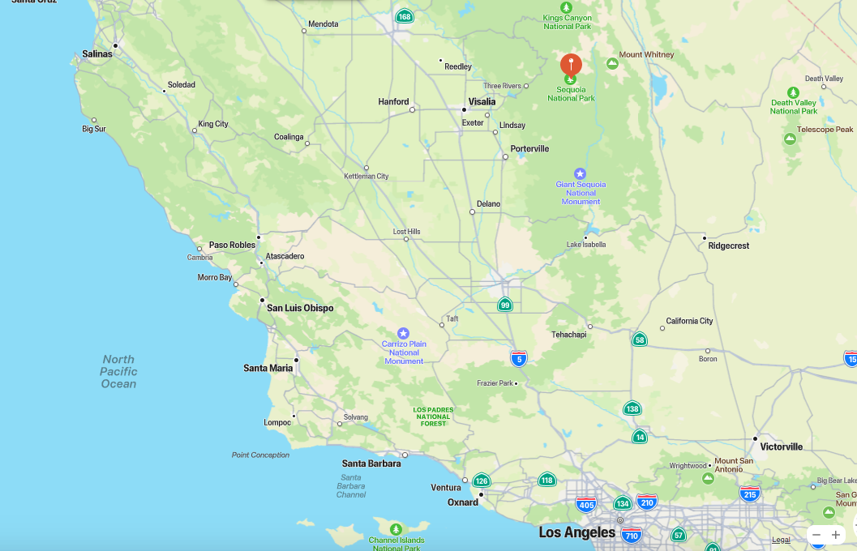

Assignment 2
- giant trees | o. very, very big trees
- to wrap | c. to cover something by putting a piece of material around it
- wildfires | d. fires in wild areas that spread very quickly and can cause great damage
- massive | l. very large
- sequoia | n. a very tall tree which grows in California
- intense | m. very strong
- substance | g. a material of a particular kind
- to trigger | b. to cause to happen
- seeds | k. small pits made by a plant from which new plants can grow
- endangered | e. in danger, especially of animals or plants that are in danger of dying out
- to approach | i. to move or become near or nearer to something
- wrapping material | h. material used to cover something up
- 77 square miles | a. 200 km²
- to clear | j. to remove things from an area or a place to make it empty
- drought | f. a long period of time with very little or no rain

Assignment 3
a True:
2 ... belong to the largest trees in the world.
3 ... can become larger than 300 feet.
4 ... can become more than 3000 years old.
6 ... normally die by falling over.

b 2 They help spread the tree seeds and new trees can grow in the place of burnt down trees.

c 2 They clear areas around the trees.
5 They use planes and helicopters to drop water in the area around the trees.
6 They wrap the trees with a special material made of aluminum.

